**Adam Ridhwan Amir Hamzah**

**CS701 Rich Internet Application**

**Final Project - Job Application Tracker**

Job Application Tracker is an application that allows users to keep track of all the job applications that they applied for. When applying for jobs, its common to apply to many different companies especially when it is a software engineering role. The applications help users be more organized with their applications and keep track of the status of each application. Users can enter the company name, location, application method, stage of application, position, interview type and the interview date, and have them saved into their local storage.

GUI

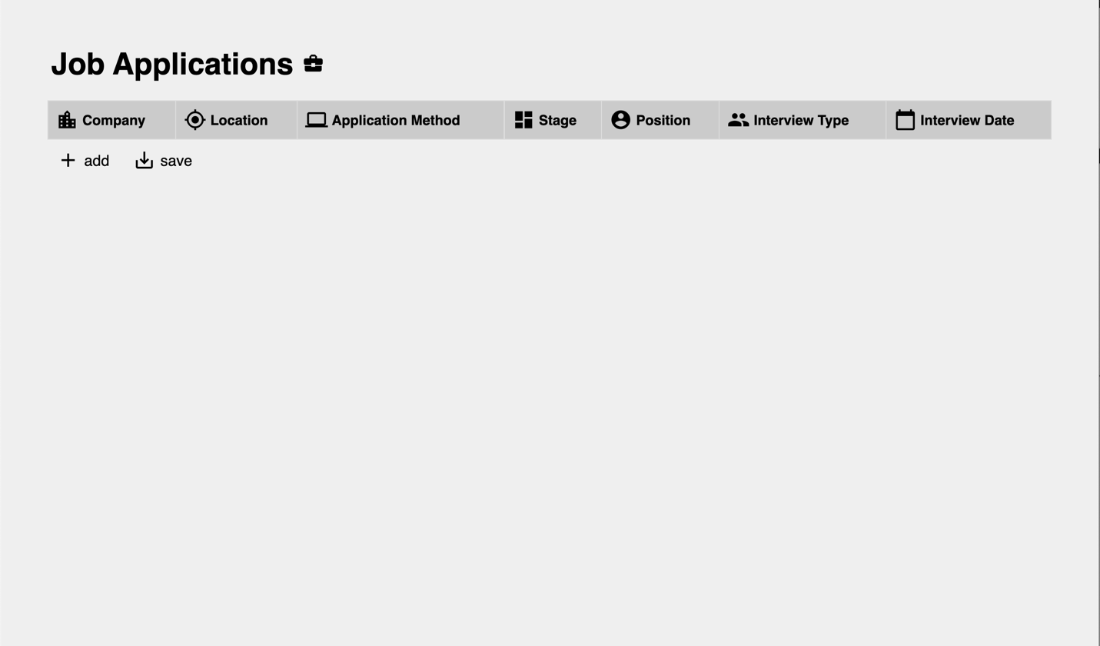

* When there is no data in user’s local storage, nothing will be shown on the page
* There are currently two function buttons: add & save
  + add = allows users to add entry on to the page. Routes them to the ‘add’ page
  + save = save current entries to local storage after user finishes editing entries

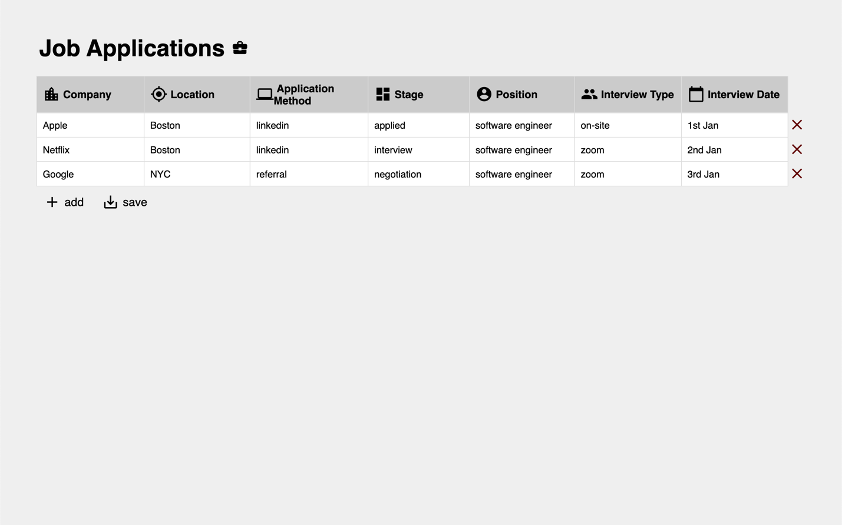

* When there is data in local storage, data will be shown on page
* Each entry has a delete button, which allows users to delete an entry
* Each entry is also editable as a way to update their application.

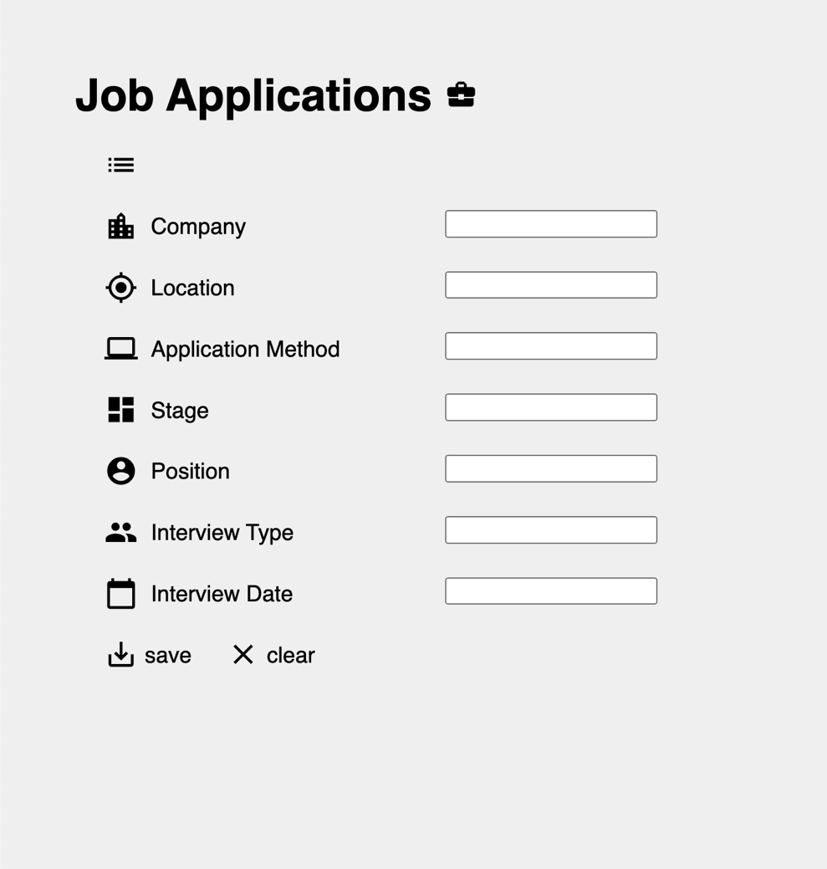

* When user clicks on add button on main page, user is routed to a ‘add’ page, which allows them to add an entry
* It has three buttons:
  + top-right button: routes user back to main page
  + save: save entry
  + clear: clears entry
* when user tries to saves empty fields, nothing will be saved to local storage

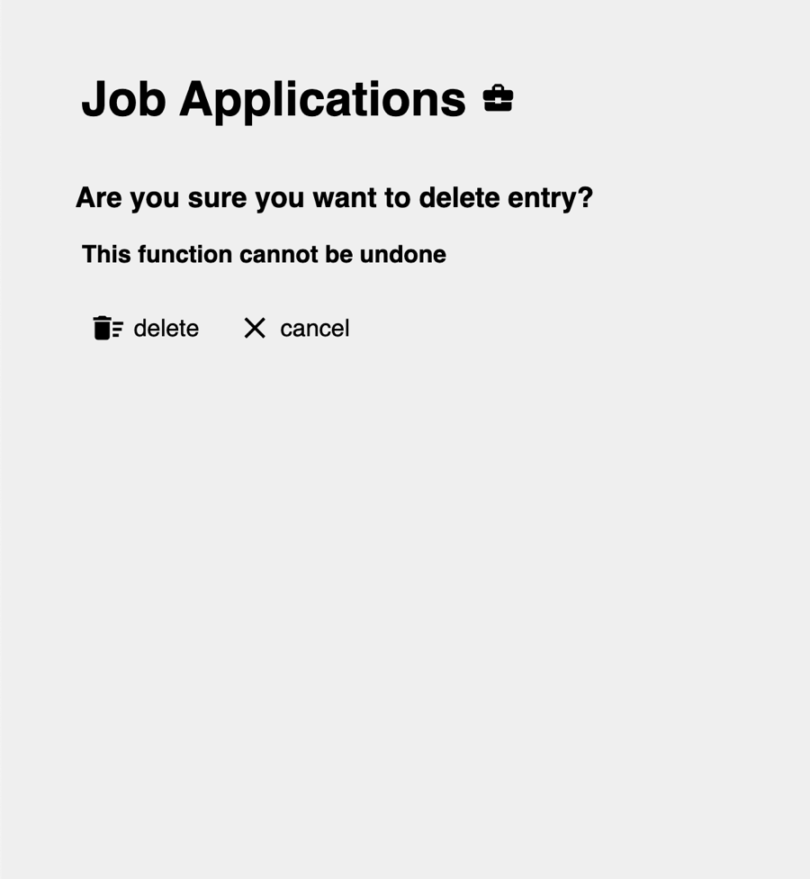

* When delete button is clicked on the main page, user is routed to a ‘delete’, which allows them to delete an entry.
* It has two buttons:
  + delete: confirms deletion of an entry
  + cancel: cancels deletion and routes back to main page